Retail Store Sales and Profit Analysis using Excel and Power BI
1. Project Overview and Objective
The objective of this project is to clean, transform, analyze, and visualize retail sales data using Excel and Power BI to generate meaningful business insights and create an interactive dashboard.
The main objective is to demonstrate data pre-processing techniques using Excel and an interactive Power BI dashboard visualization to make informed decisions.

2. Data Sources
- Source Description and Timeline: Retail Store Sales Dataset containing order, customer, product, sales, quantity, discount, and profit information and 2023-2026.
- Domain: Retail / Sales Analytics

3. Problem Statement
• To analyse sales performance across different regions and customer segments.
• To identify top-performing products based on sales revenue.
• To evaluate profit trends across product categories and sub-categories.
• To examine the impact of discounts on overall sales and profitability.
• To create an interactive Power BI dashboard that supports data-driven business decision-making.

4. Attribute (Column /Features) Details:
Attribute Name | Data Type | Description
Order ID | String (Text) | Unique identifier for each order
Order Date | Date | Date on which the order was placed
Ship Date | Date | Date on which the order was shipped
Customer ID | String (Text) | Unique identifier for each customer
Customer Name | String (Text) | Name of the customer
Segment | Categorical (Text) | Customer segment (Consumer, Corporate, Home Office)
Region | Categorical (Text) | Sales region (East, West, North, South)
Category | Categorical (Text) | Product category (Furniture, Technology, Office Supplies)
Sub-Category | Categorical (Text) | Product Sub-Category
Product Name | String (Text) | Name of the product sold
Sales | Decimal (Numeric) | Revenue generated from the sale
Quantity | Integer (Numeric) | Number of units sold
Discount | Decimal (Numeric) | Discount applied to the product
Profit | Decimal (Numeric) | Profit earned from the sale
Profit Status | Categorical (Text) | Indicates whether the transaction resulted in profit or loss

5. Tools & Technologies
- Excel: Data cleaning, transformation, and Pivot Tables.
- Power BI: Data modelling, DAX calculations, visualization, and interactive dashboard creation.

6. Data Pre-Processing (Excel / Power Query)
Tasks Performed:
- Converted the raw dataset into an Excel Table for better data management.
- Created a backup copy of the original dataset in a separate sheet (Dummy Data).
- Standardized data types for Order Date, Ship Date, Sales, Quantity, Discount, Profit, and other fields.
- Applied proper formatting and alignment to the dataset.
- Removed leading and trailing spaces using the TRIM() function.
- Standardized customer names using PROPER() function.
- Removed prefixes/suffixes and designations such as Mr., Mrs., Ms., PhD, etc.
- Identified duplicate records using Conditional Formatting.
- Handled missing values:
- Customer Name → filled with "Unknown"
- Segment, Region, Discount and other categorical fields → imputed using Mode
- Created a calculated column Profit Status using IF condition:
- Profit > 0 → Profit
- Profit < 0 → Loss
- Applied filtering and sorting for data validation.
- Created Pivot Tables for preliminary analysis and summarization.
- Converted the dataset into Fact and Dimension Tables for Power BI data modeling.
- Validated data in Power Query and removed unwanted null rows.

7. Data Modelling and DAX (Power BI)
- Data Model: Established relationships between tables, defined cardinality, and created lookup tables where necessary.
- Data Model:
- Created Fact Sales Table.
- Created Dimension Tables:
Customer Dimension
Product Dimension
Region Dimension
Date Dimension
Profit Status Dimension
- Established relationships between fact and dimension tables.
- Defined one-to-many cardinality relationships.
Calculated Columns & DAX Measures
Total Sales = SUM(Sales)
Total Profit = SUM(Profit)
Total Orders = COUNT(Order ID)
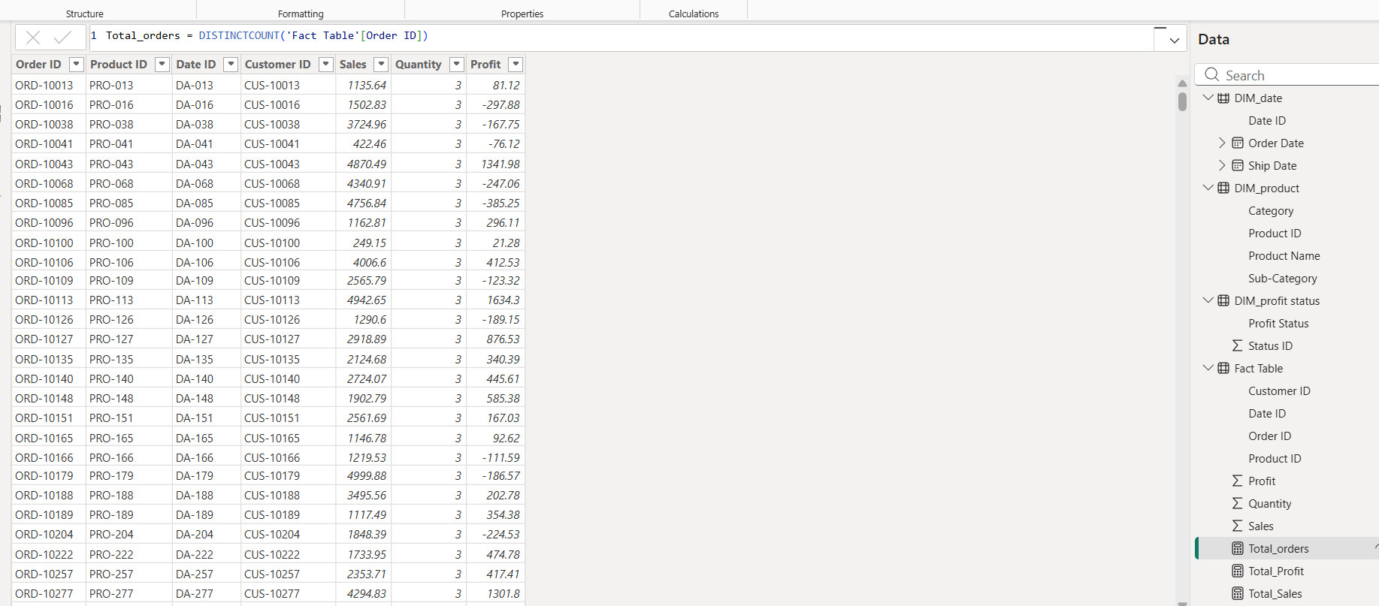
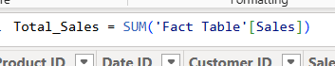
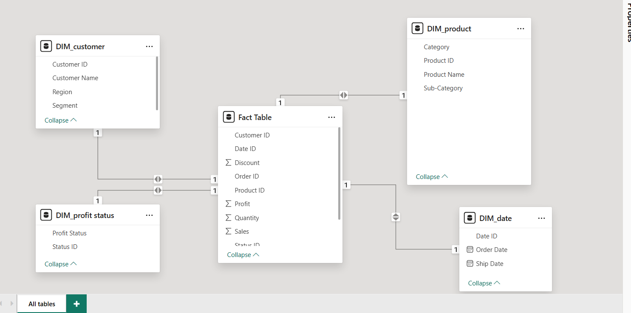

8. Analysis and Visualizations (Power BI)
Dashboard Features:
- KPI Cards:
- Total Orders
- Total Sales
- Total Profit
- Visualizations:
- Sales by Region (Clustered Bar Chart)
- Sales by Segment (Pie Chart)
- Top 5 Products by Sales (Bar Chart)
- Sales by Year (Line Chart)
- Profit by Category (Bar Chart)
- Sales and Discount by Profit Status (Bar Chart)
- Interactive Slicers:
- Order Date
- Region
- Segment
- Category
- Applied Black & Grey Dashboard Theme.
- Added Dashboard Title:
- Retail Performance Dashboard
- Added labels, legends, titles, and interactive filtering.
SCREENSHOT OF DASHBOARD /REPORT
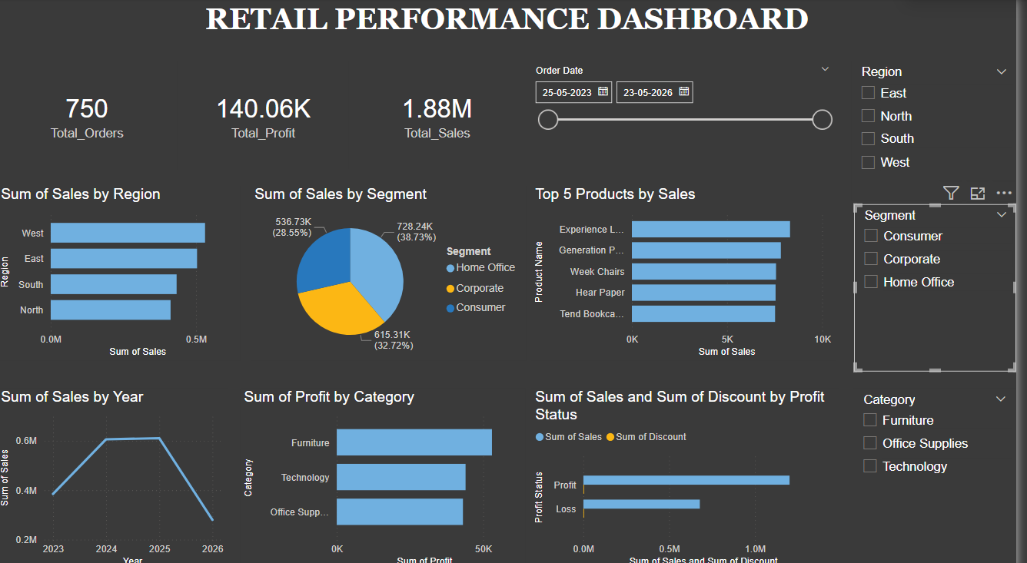

9. Insights & Conclusions
- Key Findings: Summarize trends, patterns, or anomalies identified in the data
- Insights:
Descriptive
  - West region recorded the highest sales.
  - Home Office segment generated the highest sales contribution.
  - Furniture category generated the highest profit.
  - A few products contributed significantly to overall sales.
Diagnosis
  - Descriptive Insights
  - West region recorded the highest sales.
  - Home Office segment generated the highest sales contribution.
  - Furniture category generated the highest profit.
  - A few products contributed significantly to overall sales.
  - Diagnostic Insights
  - Higher discounts were associated with lower profitability in some transactions.
  - Loss-making transactions were concentrated in specific products and categories.

Predictive
  - High-performing products are likely to continue driving future sales.
  - Regions with consistent growth may contribute more revenue in upcoming periods.
Prescriptive
  - Focus marketing efforts on top-selling products.
  - Reduce excessive discounts on low-profit products.
  - Improve inventory planning for high-demand categories.
  - Prioritize profitable regions and customer segments for business growth.

10. Conclusions
The retail sales data was cleaned, transformed, and analyzed using Excel and Power BI. Key sales and profit trends were identified across regions, segments, and categories. An interactive dashboard was developed to support business insights and decision-making.

